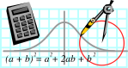  Rossmoyne SHS  Mathematics  Department | MATHEMATICS SPECIALIST 3AB | Semester 1 2010  EXAMINATION

NAME:
TEACHER: Mrs.Benko Mr.Longley
Ms.Robinson

Section One:
Calculator-free

Time allowed for this section
Reading time before commencing work: 5 minutes
Working time for this section: 50 minutes

Material required/recommended for this section

To be provided by the supervisor
This Question/Answer Booklet
Formula Sheet

To be provided by the candidate
Standard items: pens, pencils, pencil sharpener, eraser, correction fluid, ruler, highlighters

Special items: nil

Important note to candidates
No other items may be used in this section of the examination. It is your responsibility to ensure that you do not have any unauthorised notes or other items of a non-personal nature in the examination room. If you have any unauthorised material with you, hand it to the supervisor before reading any further.

Structure of this paper

Section | Number of questions available | Number of questions to be answered | Working time (minutes) | Marks available
Section One:  Calculator-free | 8 | 8 | 50 | 40
Section Two:  Calculator-assumed | 14 | 14 | 100 | 80
 |  |  |  | 120

Instructions to candidates

1. Write your answers in the spaces provided in this Question/Answer Booklet. Spare pages are included at the end of this booklet. They can be used for planning your responses and/or as additional space if required to continue an answer.
  - Planning: If you use the spare pages for planning, indicate this clearly at the top of the page.
  - Continuing an answer: If you need to use the space to continue an answer, indicate in the original answer space where the answer is continued, i.e. give the page number. Fill in the number of the question(s) that you are continuing to answer at the top of the page.

2. Show all your working clearly. Your working should be in sufficient detail to allow your answers to be checked readily and for marks to be awarded for reasoning. Incorrect answers given without supporting reasoning cannot be allocated any marks. For any question or part question worth more than two marks, valid working or justification is required to receive full marks. If you repeat an answer to any question, ensure that you cancel the answer you do not wish to have marked.

3. It is recommended that you do not use pencil except in diagrams.

QUESTION | MARKS AVAILABLE | STUDENT MARK
1 | 4
2 | 6
3 | 8
4 | 5
5 | 4
6 | 3
7 | 5
8 | 5
TOTAL | 40

Section one
NO CALCULATORS PERMITTED FOR THIS SECTION
Working time: 50 minutes
Available marks 40 marks

Question 1 [4 marks]
(a) Solve: 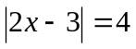
[2]

- The number line shown represents the solution to 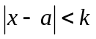. Find the values of 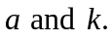
[2]

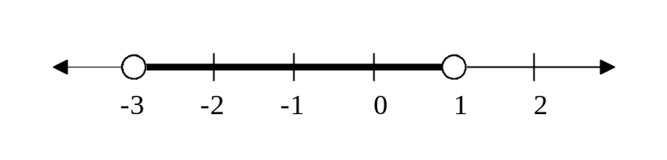

Question 2 [6 marks]
(a) Demonstrate a non graphical method to solve 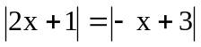
[2]

- Use your result from part (a) to find the solution to: 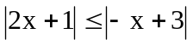
Show all working.
[3]

- Graph your solution on the provided number line.
[1]
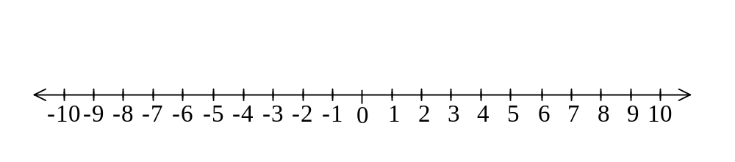
Question 3. [8marks]
(a) Rewrite 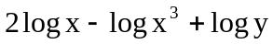 as the logarithm of a single term.
[2]

- Find N if 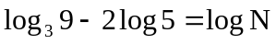
[3]

- Find an expression for x if: 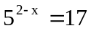
[3]

Question 4 [5 marks]
(a) Change the polar point 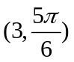 to exact Cartesian coordinates.
[2]

(b) Find the area of the triangle whose vertices are at the polar points 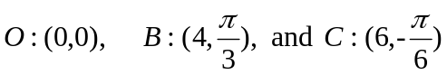
[2]

(c) What other position might C have if the new triangle OBC has the same area as in part (b)?
[1]

Question 5 [4 marks]
Write each of the vectors m and n below in terms of the given vectors a and b

a
b
m
n

(a) m =
[2]

(b) n =
[2]

Question 6 [3 marks]
Calculate the area of the sector shown with OB = OA = 4cm and arc AB = 5cm.
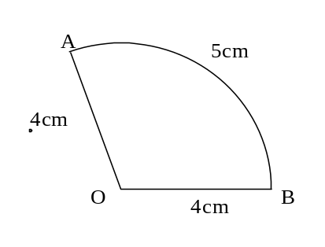

Question 7 [5 marks]
A disabled boat called “Hope” is being dragged towards an East-West reef by ocean currents moving due south with a force of 4000N. Two rescue vessels, called “Hero” and “Heroine”, are trying to prevent what appears to be an impending disaster by attaching rescue lines to Hope. Hero exerts a force of 2500 N to the North East and Heroine exerts a force of 2000N on a bearing of 330°.

Make a scale drawing using 1cm =500N and use this scale drawing to find the resultant force on the boat “Hope” and determine whether Hope will sail another day or be broken on the reef.

Question.8 [5marks]

Simplify the given expression and leave your answer as a single exponential function.

